Installation & Safety Data for KG100PSD

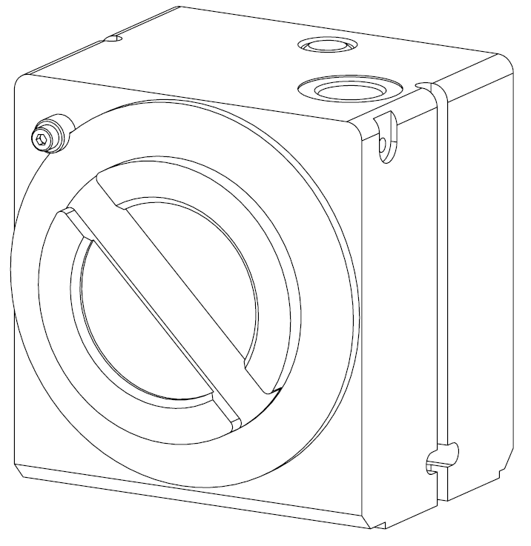
Area of use
Class I Zone 1 Group IIA T4 IP65
- This power supply and display is suitable for use in Class I Zone 1 hazardous locations and provides outputs suitable for Class I Zone 1 hazardous locations.
- The group classification is Group IIA. This includes suitability for propane, petrol, methane, ethanol, etc.
- The surface temperature classification is T4 - maximum surface temperature of 135°C.
- The ambient operating temperature range is -40°C to +70°C
- The operating atmospheric pressure range is 60 kPa to 110 kPa (approximate altitude <4500m)
- With the use of an appropriate gland, and when mounted with a KG100 Meter (with CI545) this enclosure provides a degree of protection of IP65.
- Maximum voltage Um: 250 V (this is a safety limit – not an operating rating). Um applies to non‑intrinsically safe circuits, specifically the Mains input (J100), 12 VDC input (J101), and RS485 interface (J300). It does not apply to intrinsically safe circuits or connectors.

Cable entries
There is only one cable/conduit entry which is at the bottom of the box. The cable/conduit entry is an M20x1.5mm thread with thread depth of 20mm.
Cable glands and connected cables shall be suitable for a minimum service temperature of 80°C
If a thread adapter is necessary, use only an appropriately certified adapter.

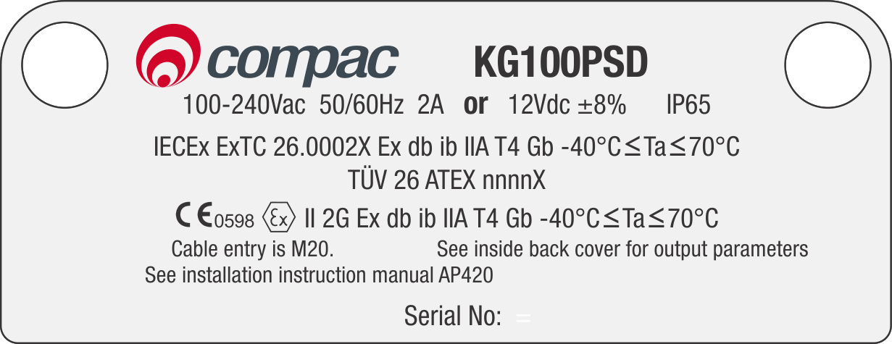
Certification
The KG100PSD is in compliance with:
IEC Standards:
- IEC 60079-0 ed 7.0 (2017)
- IEC 60079-1 ed 7.0 (2014)
- IEC 60079-11 ed 7.0 (2023)
EN Standards
- EN IEC 60079-0:2018
- EN 60079-1:2014
- EN IEC 60079-11:2024
The KG100PSD has IECEx and ATEX certification. The label shown will be attached to the display fascia.
This equipment has been constructed in accordance with the safety requirements of relevant industrial standards.

Opening the flameproof box lid
- Always disconnect power (isolate all circuits).

- Remove the lid using a hook spanner.

Closing the flameproof box lid
- Ensure the o-ring is sitting correctly in the o-ring groove of the lid.
- Ensure the threaded surfaces are clean, free of debris, and undamaged.
- Align the lid with the enclosure threads carefully to avoid cross-threading.
- Rotate the lid clockwise by hand until resistance is felt.
- Use hook spanner for final tightening and tighten until the lid is fully seated against the enclosure body.

Calibration
The display cover is secured with four M4 screws. Each screw has a hole in its head for threading a sealing wire, which prevents tampering after calibration.
To adjust calibration:
- If present, remove the sealing wire and then unscrew the four M4 screws securing the display lid.
- Remove the display lid along with the glass window and O-ring to access switch SW200.
- Press switch SW200. The CAL indicator will illuminate, confirming that calibration mode is active.
- Use the external button on the top or bottom of the power supply enclosure to adjust the calibration.
- When reinstalling the display lid, make sure its orientation aligns with the display.

Display Orientation
This meter supports two power supply positions: beneath the meter or on top. For gas measurements, the power supply is typically at the bottom. To accommodate both configurations, the display can be rotated 180°.
Steps to rotate the display:
- If present, remove the sealing wire and then unscrew the four M4 screws securing the display lid.
- Remove the display lid along with the glass window and O-ring.
- Unscrew the four screws securing the display PCB (CI543).
- Lift the top board disconnecting the connector linking the top and bottom boards.
- Rotate the top board 180°, and reinstall it, ensuring the connector pins align correctly.
- Note: The display window is offset within the lid. When reinstalling, make sure the opening aligns with the display. If the display is rotated, the lid must also be rotated 180° to match.

Installation
- Ensure that any limitations specified on the relevant certificates for the certified glands or adapters used in the assembly, are observed.
- Use appropriately rated glands and adapters if the IP65 rating of the equipment is to be maintained.
- Connect the power supply to only one input:
- J100 for a mains supply (100–240 VAC, 50/60 Hz, 2 A), or
- J101 for a 12 VDC supply (0.5 A).
Do not use both inputs simultaneously.

 Earthing

Earthing with Mains Input
When the mains input is being used, the main incoming earth should be connected to the internal earthing facility. The earth lead must have a cross-sectional area at least equal to the largest live conductor.

Earthing with 12Vdc Input
When the 12Vdc input is being used the enclosure still needs to be earthed. This can be done in several ways:
- it is recommended to run a separate protective earth wire in the cable and connect this to the internal earthing facility, or
- connect an external earth to the external earthing facility on the enclosure, or
- use the -ve wire of the 12V supply as the protective earth wire but then ensure it is suitably bonded to earth at the source and connected to the internal earthing facility.

External Earth Facility
The external earthing facility is suitable for a lug with up to a 4-mm² conductor. The main earth connection is to be made using the internal, external, or both earthing facilities. The connection to the external earthing facility is to be made using a brass or zinc-plated steel washer on each side of the lug and a brass or zinc-plated steel M5 x 8 mm screw to fix it to the flameproof box.
If there is a requirement for electrical bonding, then the external earthing facility can be used. The earth lead must have a cross-sectional area at least equal to the largest live conductor.

 Terminal wiring
- All wiring must be carried out in accordance with the relevant code of practice and/or instructions e.g., IEC 60079-14 or EN 60079-14
- All mains wiring must have a cross-sectional area of 0.5 to 4 mm^{2.}
- The voltages shown on the label must not be exceeded.
-  The wiring used should be suitable for 80°C.
- The wiring insulation must extend to within 1 mm of the metal face of the terminal.
- All wiring must be suitably insulated for the maximum voltage.
- Not more than one single or multi-stranded conductor shall be connected into each terminal unless the conductors have been pre-joined in an appropriate manner (e.g., with an insulated crimped bootlace ferrule)

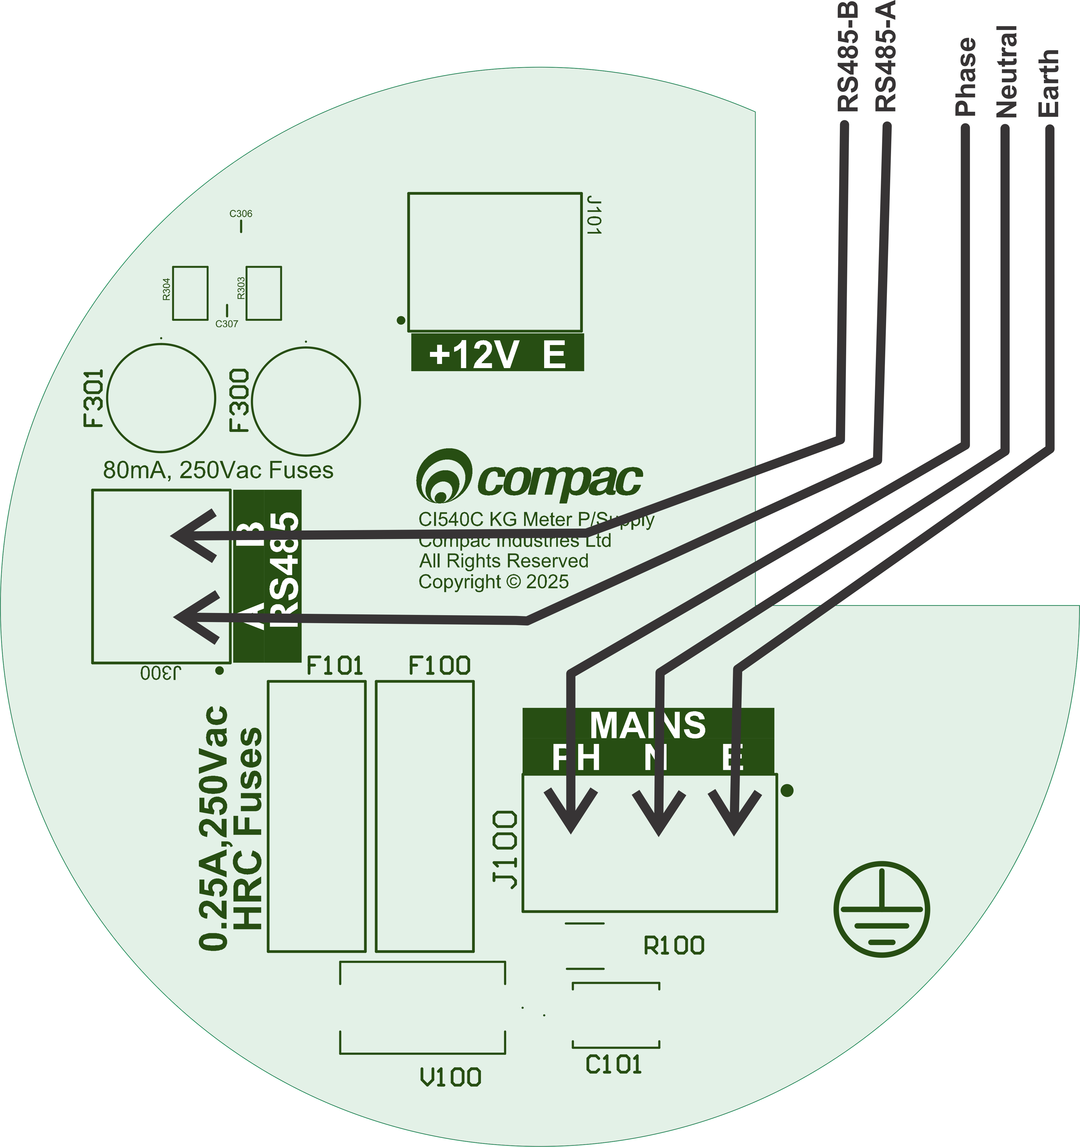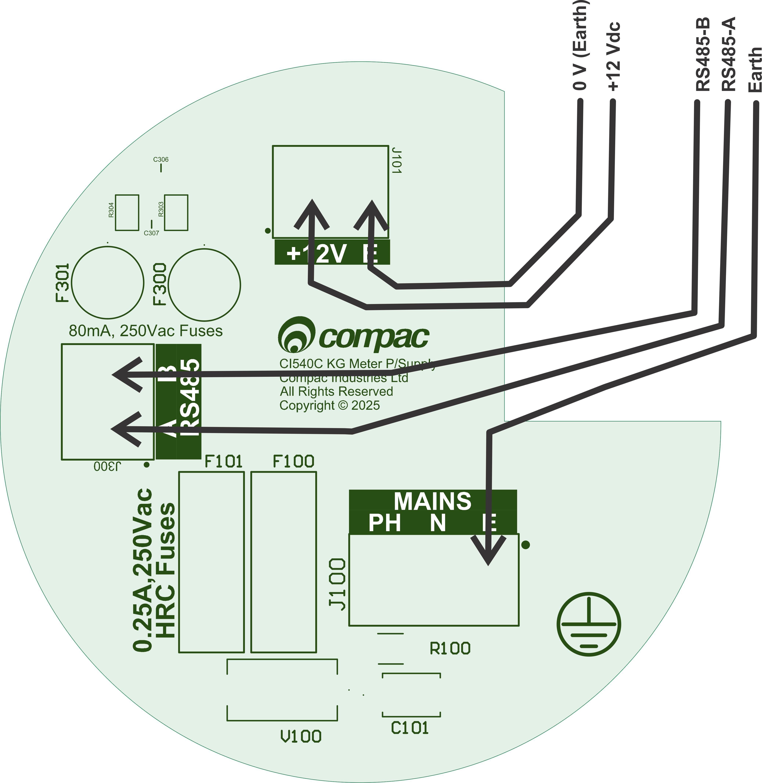
Connection of mains or 12V and RS485 cables.

Mains Supply (J100)
Note: Connect either the mains supply or the 12 Vdc supply. Although both may be connected simultaneously without causing damage, this is not recommended.
The input mains supply is rated for 100 to 240 Vac, 50/60Hz, 2A, OVC I/II/III
The Mains supply must be supplied via an appropriately rated switch or circuit-breaker that is suitably located, easily reachable, and marked as the disconnecting device for this equipment.

Mains Fuses
There are two serviceable fuses: F100 & F101. Always replace these fuses with one of the fuses listed here.
F100 & F101 are 0.25 A, 250 Vac, 1500A breaking capacity fuses and must be replaced with one of the following.
- Bel Fuse 5HT-250-R or
- Little Fuse 0215.250MXP
- OptiFuse TCD-250MA

12V Supply (J101)
Note: Connect either the mains supply or the 12 Vdc supply. Both may be connected simultaneously without causing damage, but this is not recommended.
The input 12V supply is rated for 12Vdc±8%, 200mA, OVC I/II. The device includes protection against input voltages up to 80 V and reverse polarity; however, prolonged exposure to these conditions can lead to permanent damage.
The 12V supply must be supplied via an appropriately rated switch or circuit-breaker that is suitably located, easily reachable, and marked as the disconnecting device for this equipment.

RS485 (J300)
The RS485 (MODBUS) is isolated from earth with 3kVac/1s isolation. It is suitable for OVC I/II/III circuit. Maximum baud rate is 38400. It is not terminated and should not need to be terminated unless the network is over 50m.
The RS485 A/B circuit can be run in the same cable as the supply.

The RS485 circuit shall be supplied through a suitably rated switch or circuit breaker that is mechanically ganged or otherwise interlocked with the primary supply switch or circuit breaker. Where ganging or interlocking is not feasible, both the RS485 and primary supply devices must be clearly labeled to indicate that both must be disconnected to isolate this equipment.

Internal Connection
# .

The intrinsically safe equipment connected to the DSub15 connector
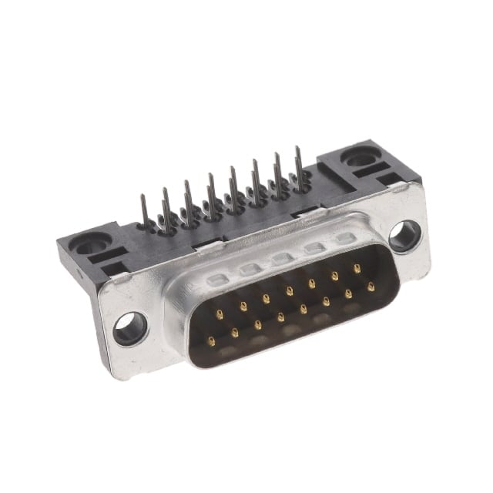
This equipment is designed to have a KG100 meter with CI545 plugged onto the DSub15 connector. In future other meters may be able to connect to this equipment.

I.S. Output
The output of this equipment provides a single Intrinsically Safe circuit with connections to J203 which is a male D-Sub15 connector.
The output parameters for this intrinsically safe supply are shown below.

KG100PSD I.S. Output pins | Associated Apparatus Parameters | Must be | Hazardous Area/  Hazardous Locations  Device Parameters | KG100 with CI545 Parameters
Pin Nos
1 to 15 | Uo = 6 V | ≤ | Ui | Ui = 6 V
 | Io = 225 mA | ≤ | Ii | Ii = 235 mA
 | Co = 220 µF | ≥ | Ci | Ci = 137 µF
 | Lo = 50 µH | ≥ | Li | Li = 50 µH
 | P_{O} = 1 W | ≤ | Pi | Pi = 1.1 W
5, 8, 9, & 15 | Earth |  | Common Earth

Conditions of use pertaining to the certification of this equipment
- The flame paths are not intended to be repaired.
- Only cable glands and thread adapters which have been separately certified to IEC 60079-0 and IEC 60079-1 shall be used.
- The 12V DC input shall only be connected to a circuit with overvoltage category (OVC) II or lower.
- The intrinsically safe output circuits are bonded to the metallic enclosure, and this must be taken into account when interconnecting in the system.

